Red Oak Hardwood Deals Product Guide
Large print edition
This guide presents five Red Oak flooring deals in large, high-contrast type. Each product page includes a flooring image, current inventory, construction details, installation methods, and an easy-to-read specification table.

Deals at a glance
- Oak Plank Red Oak Natural 3.25 inch Builder A $2.29 per square foot
- Winchester Red Oak Natural 2.25 inch Builder Grade $2.29 per square foot
- Antique S Red Oak Natural 2.25 inch Builder Grade $2.29 per square foot
- Oak Lakes Red Oak Natural 4 inch Cabin Grade $2.99 per square foot
- Chateau Oak Red Oak Natural 5 inch First Quality $3.29 per square foot
Inventory checked September 22, 2026. Prices and quantities can change. Call 1-800-253-2728 to confirm availability and place an order.

Oak Plank
Red Oak Natural 3.25 inch Builder A
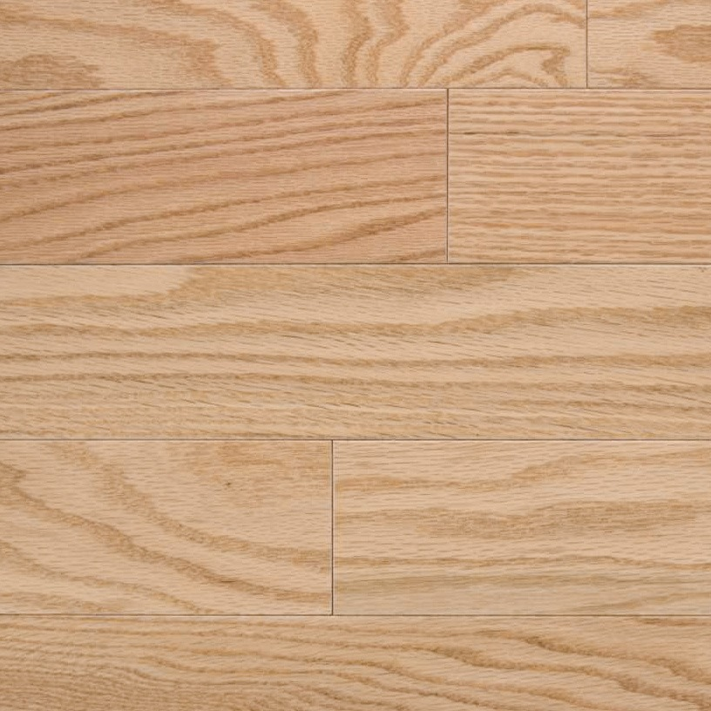
$2.29 per square foot
Engineered hardwood value option
Product specification | Value
Color and species | Red Oak Natural, Red Oak
Width and quality | 3.25 inches, Builder A
Available | 1,120 square feet
Construction | Engineered, 8-ply cross-grain core, 1/2 inch thick
Wear layer and finish | 3 millimeters, smooth semi-gloss, UV-cured aluminum oxide
Installation | Nail, staple, glue, or float; approved for radiant heat
Packaging | 40 square feet per box
View product details page

Winchester
Red Oak Natural 2.25 inch Builder Grade
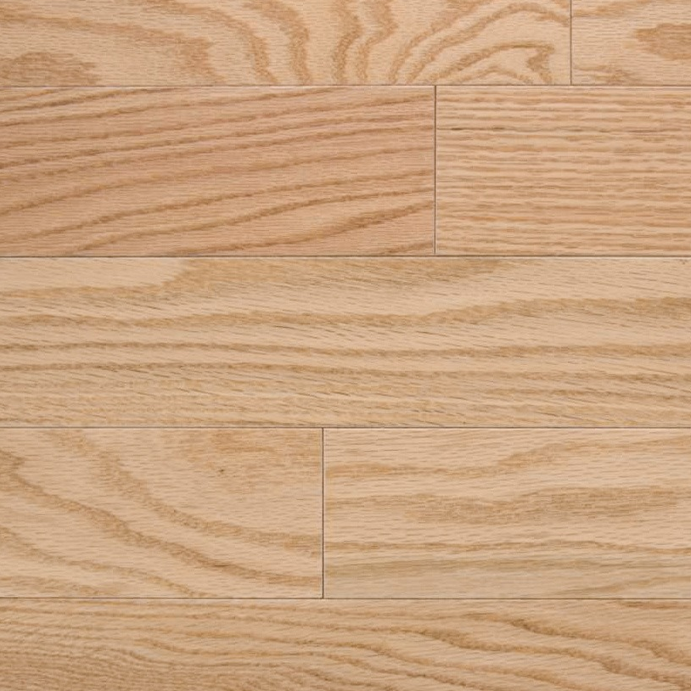
$2.29 per square foot
Limited quantity solid hardwood
Product specification | Value
Color and species | Red Oak Natural, Red Oak
Width and quality | 2.25 inches, Builder Grade
Available | 600 square feet
Construction | Prefinished solid hardwood, 3/4 inch thick
Hardness and finish | Janka 1,290, UV-cured aluminum oxide, eased edges and ends
Installation | Nail or staple; not approved for radiant heat
Packaging | 25 square feet per box
View product details page

Antique S
Red Oak Natural 2.25 inch Builder Grade
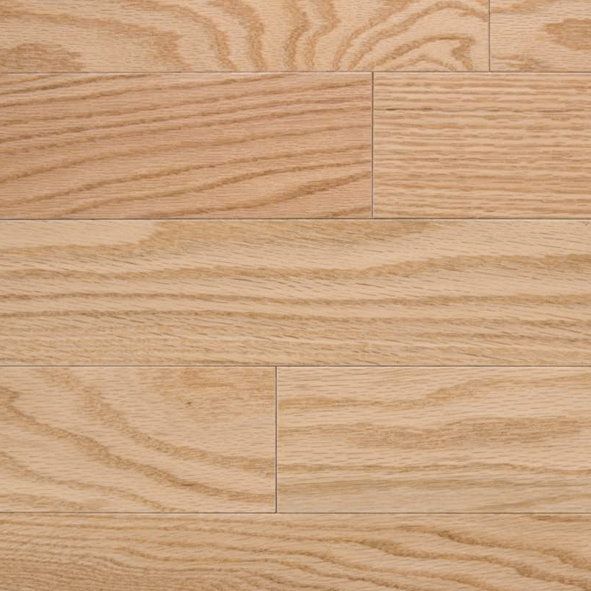
$2.29 per square foot
Confirm availability because the page also shows backorder status
Product specification | Value
Color and species | Red Oak Natural, Oak
Width and quality | 2.25 inches, Builder Grade
Inventory listed | 700 square feet; page also indicates backorder
Construction | Prefinished solid hardwood, 3/4 inch thick
Appearance and finish | Wire-brushed, low gloss, low color variation, UV-cured aluminum oxide
Installation | Nail or staple; not approved for radiant heat
Packaging | 25 square feet per box
View product details page

Oak Lakes
Red Oak Natural 4 inch Cabin Grade
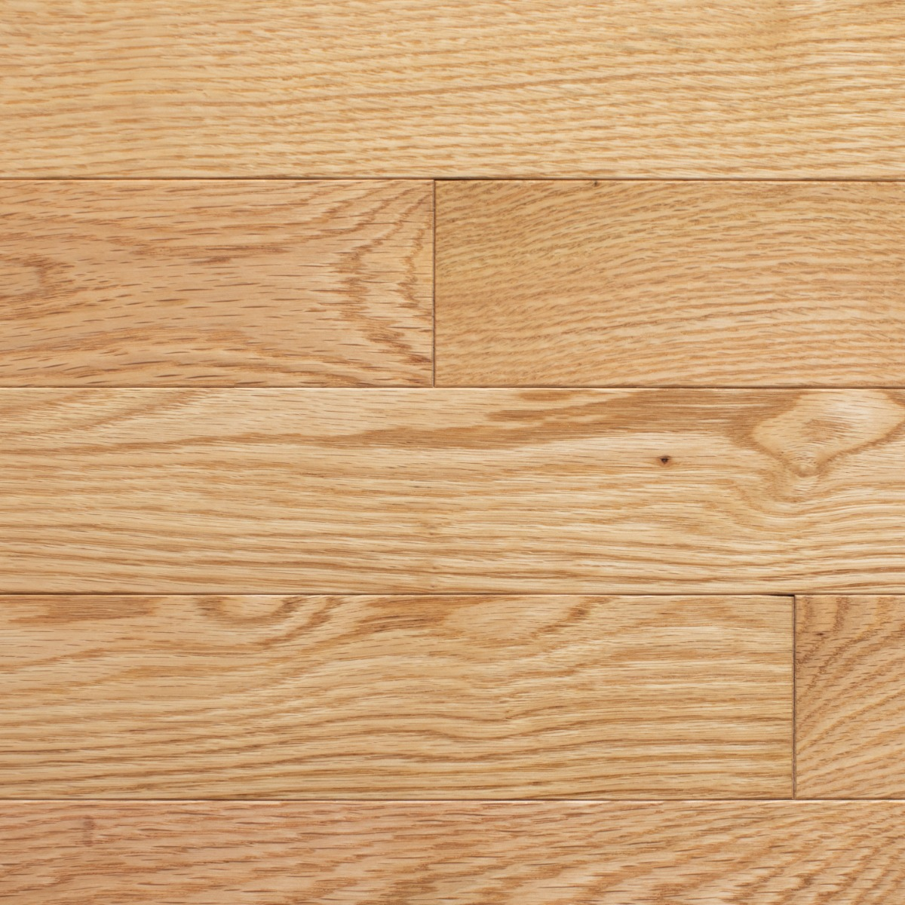
$2.99 per square foot
Special campaign price reduced from $3.49
Product specification | Value
Color and species | Red Oak Natural, Red Oak
Width and quality | 4 inches, Cabin Grade
Available | 8,816 square feet
Construction | Prefinished solid hardwood, 3/4 inch thick
Appearance | Medium gloss, eased edge and square end
Installation | Nail or staple; not approved for radiant heat
Packaging | 16 square feet per box; Murphy, North Carolina warehouse
View product details page

Chateau Oak
Red Oak Natural 5 inch First Quality
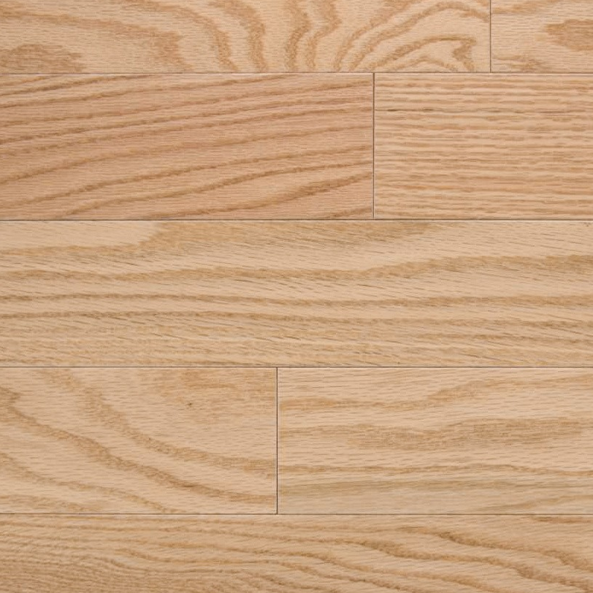
$3.29 per square foot
First Quality engineered hardwood
Product specification | Value
Color and species | Red Oak Natural, Red Oak
Width and quality | 5 inches, 1st Quality
Available | 15,040 square feet
Construction | Engineered, 7-ply birch core, 1/2 inch thick
Wear layer and finish | 3 millimeters, matte finish, four-sided bevel
Installation | Nail, staple, glue, or float; approved for radiant heat
Packaging | 40 square feet per box
View product details page

